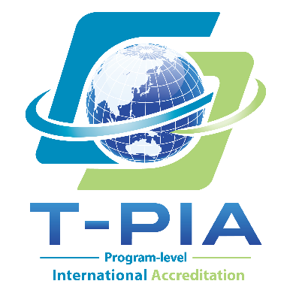
--------- TWAEA Program-level International Accreditation ---------
APPLICATION FORM
Part I. Institutional Information
Institution Name
Country
Institution Address
Number of Academic Units
Total Number of Full-time Faculty Members
Total Student Enrollment
Institution Website
Part II. Applicant Programs
No. | Applicant Program Name | No. of Full-time Faculty Members | Program Level | Current  Enrollment | Year Established
Example* | Department of Business Administration | 14 | Bachelor's Program | 205 | 1999
Example* | Department of Business Administration | 14 | Master's Program | 36 | 2018
Example* | Department of Business Administration | 14 | Doctoral Program | 12 | 2018
1
2
3
* The example above is provided for reference only. Please delete it before completing the form and enter the information for each program submitted for accreditation. A separate Applicant Program Information Sheet must be completed for each applicant program.
** If additional space is required, please add rows as necessary.
Part III. Contact Information
Coordinator
Title
Office / Unit
Email
Telephone
Part IV. Declaration
The Applicant Institution certifies that all information provided in this Application Form and the accompanying Applicant Program Information Sheet(s) is accurate and complete. The institution agrees to comply with the applicable requirements, procedures, and policies of the TWAEA Program-level International Accreditation process.

Authorized Institutional Representative (President or Equivalent):
Title:
Signature / Official Stamp (if applicable):
Date:

